Data 1042:

**Tương quan burden ~ res + insured:**

1. **Mô hình hồi quy normal**

* Cơ sở toán học

burden[i] = alpha + beta_res * res[i] + beta_insured * insured[i]

* Code R:

|  |
| --- |
| # Design the model  model <- bayesvl()  model <- bvl_addNode(model, "burden", "norm")  model <- bvl_addNode(model, "res", "norm")  model <- bvl_addNode(model, "insured", "norm")  model <- bvl_addArc(model, "res", "burden", "slope")  model <- bvl_addArc(model, "insured", "burden", "slope")  # Generate the stan code for model  model_string <- bvl_model2Stan(model)  cat(model_string)  # Fit the model  fit <- bvl_modelFit(model, data1, warmup = 2000, iter = 20000, chains = 4, cores = 1) |

* Code stan

|  |
| --- |
| data {  int<lower=0> Nobs; // number of observations  vector[Nobs] y;  vector[Nobs] res; // independent variable 1  vector[Nobs] insured; // independent variable 2  }  parameters {  real alpha; // intercept  real b_res; // beta for educate, etc  real b_insured;  real sigma;  }  model {  alpha ~ normal(0,100); // priors for all betas  b_res ~ normal(0,100); //  b_insured ~ normal(0,100);  y ~ normal(alpha + b_res * res + b_insured * insured, sigma); // model  }  generated quantities {  vector[Nobs] log_lik;  for(i in 1:Nobs) {  log_lik[i] = normal_lpdf(y[i] | alpha + b_res * res[i] + b_insured * insured[i], sigma);  }  } |

* Kết quả

|  |
| --- |
| 4 chains, each with iter=5000; warmup=1000; thin=10;  post-warmup draws per chain=400, total post-warmup draws=1600.  mean se_mean sd 2.5% 25% 50% 75% 97.5% n_eff Rhat  alpha 4.08 0 0.09 3.90 4.02 4.08 4.14 4.24 1485 1  b_res -1.03 0 0.04 -1.12 -1.06 -1.03 -1.01 -0.95 1502 1  b_insured -0.33 0 0.05 -0.43 -0.37 -0.33 -0.30 -0.24 1610 1  sigma 0.65 0 0.01 0.62 0.64 0.65 0.66 0.67 1763 1 |

Các hệ số hồi quy đều âm, ảnh hưởng burden ngược với res, insured???

burden ~ 4.08 -1.03 * res -0.33*insured

res có ảnh hưởng đến finacial burden nhiều hơn insured

traceplot(fit,pars = c("alpha","b_res","b_insured","sigma"))

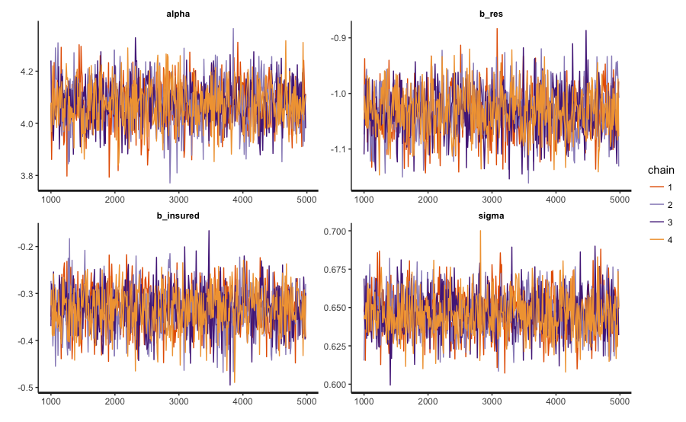

MCMC chain

Các hệ số posteriors:

stan_hist(fit,pars = params, bins = 50)

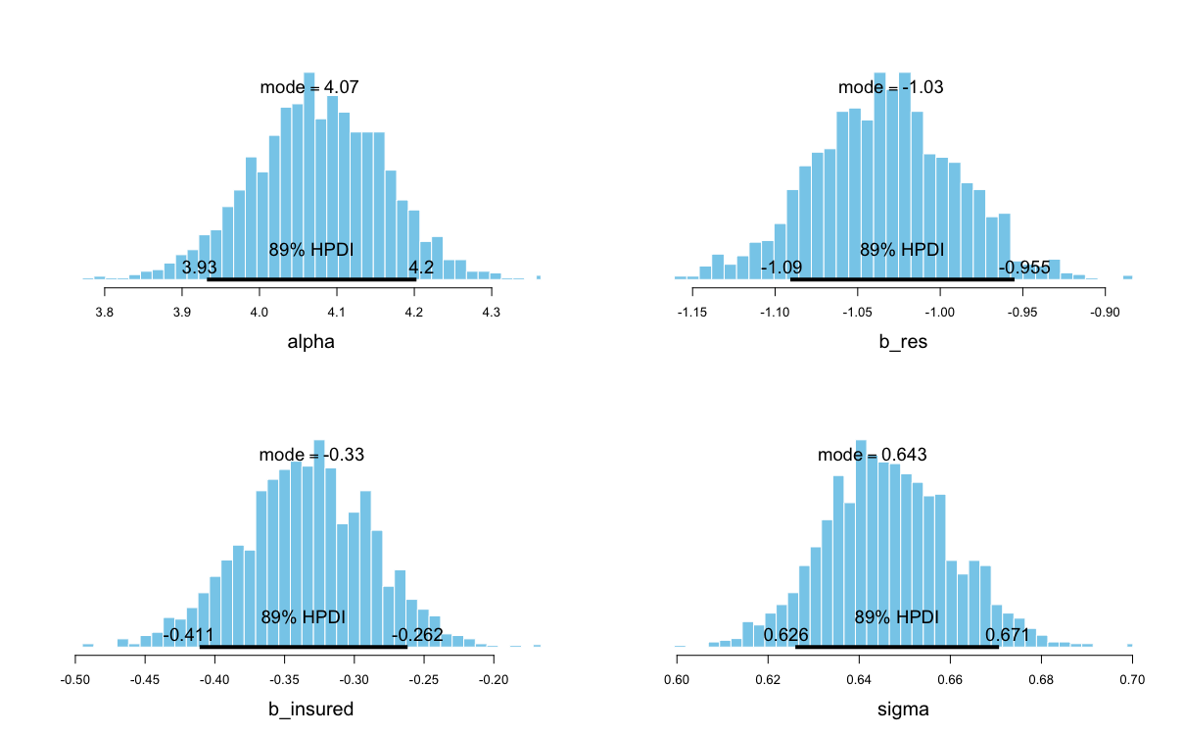

Phân phối các hệ số hồi quy

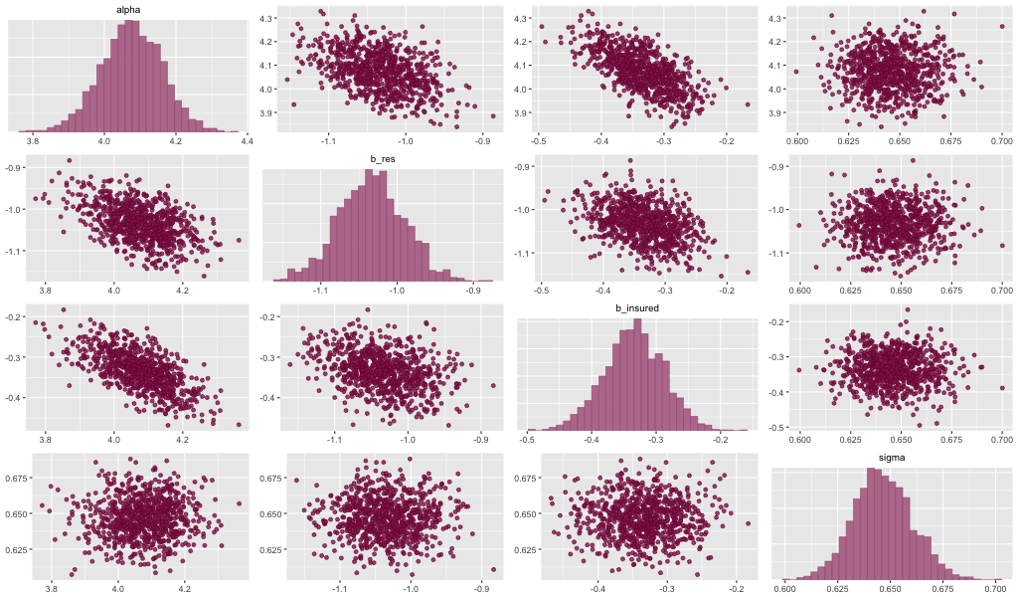

Tương quan các hệ số trong mô hình

Pair tham số:

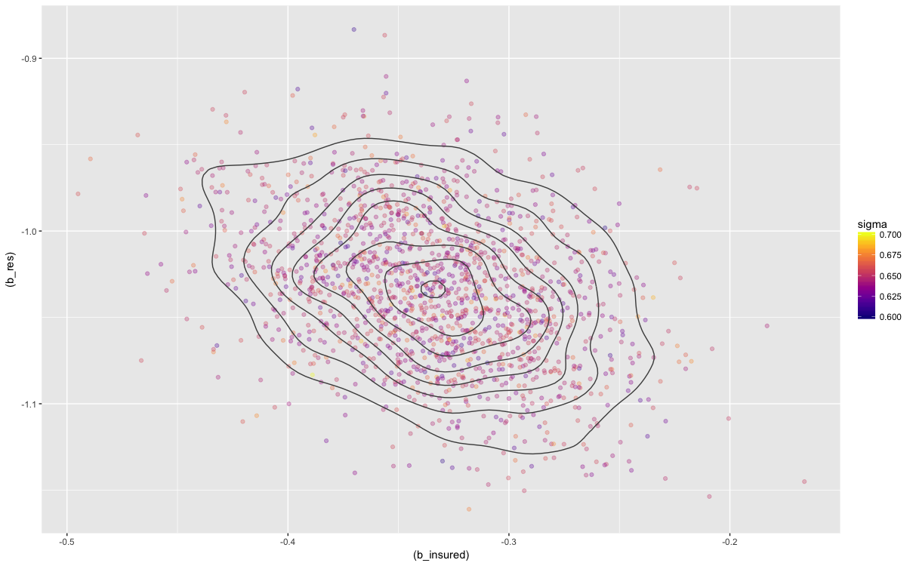

1. **Mô hình hồi quy normal**

* Cơ sở toán học

burden[i] = a_res[j,i] + b_insured*insured[i]

* Code R:

|  |
| --- |
| # Design the model  model <- bayesvl()  model <- bvl_addNode(model, "burden", "norm")  model <- bvl_addNode(model, "res", "norm")  model <- bvl_addNode(model, "insured", "norm")  model <- bvl_addArc(model, "res", "burden", "varint")  model <- bvl_addArc(model, "insured", "burden", "slope")  # Generate the stan code for model  model_string <- bvl_model2Stan(model)  cat(model_string)  # Fit the model  fit <- bvl_modelFit(model, data1, warmup = 2000, iter = 20000, chains = 4, cores = 1) |

* Code stan

|  |
| --- |
| data {  int<lower=0> Nobs; // number of observations  vector[Nobs] y; // dependent variable  int<lower=1, upper=2> res[Nobs]; // independent variable  int<lower=1, upper=2> insured[Nobs]; // independent variable  }  parameters {  real mu_res; // mean for intercepts  vector[2] a_res; // intercept estimated with 2 values  //real u_res[2];  real<lower=0,upper=10> sigma_res; // standard error for the intercept    real b_insured; // slope  real<lower=0,upper=100> sigma_y; // standard error for y  }  transformed parameters {  vector[Nobs] y_hat; // create one variable with predictions for each observation    // Varying intercepts definition  //for (k in 1:2) {  // a_res[k] = mu_res + u_res[k];  //}  for (i in 1:Nobs) // loop for all cases  y_hat[i] = a_res[res[i]] + b_insured * insured[i];  }  model {  // Prior part of Bayesian inference  mu_res ~ normal(0, 100);  a_res ~ normal(mu_res, sigma_res);  // Random effects distribution  //u_res ~ normal(0, sigma_res);    //sigma_y ~ uniform(0, 100);  y ~ normal(y_hat, sigma_y); // model  } |

* Kết quả:

|  |
| --- |
| 4 chains, each with iter=5000; warmup=2000; thin=10;  post-warmup draws per chain=300, total post-warmup draws=1200.  mean se_mean sd 2.5% 25% 50% 75% 97.5% n_eff Rhat  mu_res 2.44 0.09 3.02 -4.06 1.46 2.46 3.42 9.60 1081 1  a_res[1] 3.04 0.00 0.08 2.89 2.99 3.05 3.10 3.20 1265 1  a_res[2] 2.01 0.00 0.09 1.83 1.95 2.01 2.07 2.18 1223 1  b_insured -0.34 0.00 0.05 -0.42 -0.37 -0.34 -0.30 -0.24 1218 1  sigma_res 3.29 0.08 2.54 0.47 1.16 2.45 4.90 9.25 1075 1  sigma_y 0.65 0.00 0.01 0.62 0.64 0.65 0.66 0.68 1100 1 |

1=No, 2=Yes

NonRes

burden = 3.04 -0.34 * insured

WithRes

burden = 2.01 -0.34 * insured

